SECTION 1: Questions 1-10
Complete the form below.
Write ONE WORD AND/OR A NUMBER for each answer.

CRIME REPORT FORM
Type of crime: theft
Personal information
Example
Name Louise …Taylor…
Nationality 1 ……………….
Date of birth 14 December 1977
Occupation interior designer
Reason for visit business (to buy antique 2………………)
Length of stay two months
Current address 3 ………………. Apartments (No 15)
Details of theft
Items stolen – a wallet containing approximately 4 £ …………….
– a 5 ………………
Date of theft 6 ………………
Possible time and place of theft
Location outside the 7…………… at about 4 pm
Details of suspect – some boys asked for the 8……………. then ran off
– one had a T-shirt with a picture of a tiger
– he was about 12, slim build with 9…………… hair
Crime reference number allocated
10…………….

SECTION 2: Questions 11-15
Choose the correct letter, A, B or C.
Visit to Branley Castle
11 Before Queen Elizabeth I visited the castle in 1576,
A repairs were carried out to the quest rooms.
B a new building was constructed for her.
C a fire damaged part of the main hall.
12 In 1982, the castle was sold to
A the government
B the Fenys family.
C an entertainment company.
13 In some of the rooms, visitors can
A speak to experts on the history of the castle.
B interact with actors dressed as famous characters.
C see models of historical figures moving and talking.
14 In the castle park, visitors can
A see an 800-year-old tree.
B go to an art exhibition.
C visit a small zoo.
15 At the end of the visit, the group will have
A afternoon tea in the conservatory.
B the chance to meet the castle’s owners.
C a photograph together on the Great Staircase.

SECTION 3: Questions 16-20
Label the plan below.
Write the correct letter, A-H, next to Questions 16-20
Branley Castle
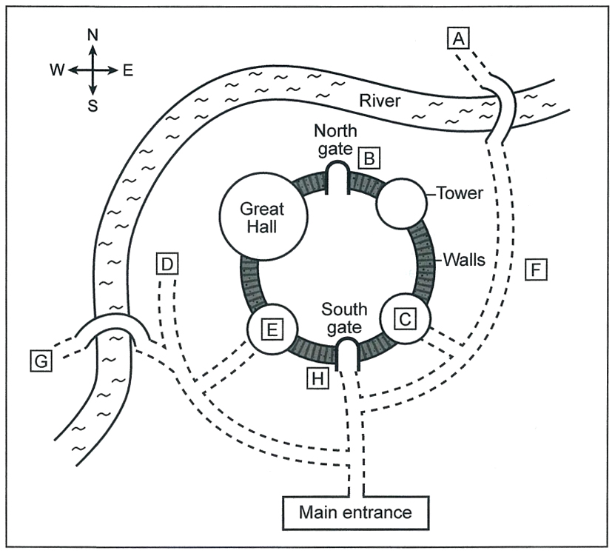
16 Starting point for walking the walls ………………
17 Bow and arrow display ………………
18 Hunting birds display ………………
19 Traditional dancing ………………
20 Shop ………………

SECTION 3: Questions 21-25

Choose the correct letter, A, B or C.

Cities built by the sea

21 Carla and Rob were surprised to learn that coastal cities

A contain nearly half the world’s population.

B include most of the world’s largest cities.

C are growing twice as fast as other cities.

22 According to Rob, building coastal cities near to rivers

A may bring pollution to the cities.

B may reduce the land available for agriculture.

C may mean the countryside is spoiled by industry.

23 What mistake was made when building water drainage channels in Miami in the 1950s?

A There were not enough for them.

B They were made of unsuitable materials.

C They did not allow for the effects of climate change.

24 What do Rob and Carla think that the authorities in Miami should do immediately?

A take measures to restore ecosystems

B pay for a new flood prevention system

C stop disposing of waste materials into the ocean

25 What do they agree should be the priority for international action?

A greater coordination of activities

B more sharing of information

C agreement on shared policies

Questions 26-30

What decision do the students make about each of the following parts of their presentation?

Choose FIVE answers from the box and write the correct letter, A-G, next to Questions 26-30.

Decisions

A use visuals

B keep it short

C involve other students

D check the information is accurate

E provide a handout

F focus on one example

G do online research

Parts of the presentation

26 Historical background ……………..

27 Geographical factors ……………..

28 Past mistakes ……………..

29 Future risks ……………..

30 International implications ……………..

SECTION 4: Questions 31-40
Complete the notes below.
Write ONE WORD ONLY for each answer.
The history of weather forecasting
Ancient cultures
- many cultures believed that floods and other disasters were involved in the creation of the world
- many cultures invented 31………………… and other ceremonies to make the weather gods friendly
- people needed to observe and interpret the sky to ensure their 32………………….
- around 650 BC, Babylonians started forecasting, using weather phenomena such as 33………………….
- by 300 BC, the Chinese had a calendar made up of a number of 34…………………. connected with the weather
Ancient Greeks
- a more scientific approach
- Aristotle tried to explain the formation of various weather phenomena
- Aristotle also described haloes and 35…………………..
Middle Ages
- Aristotle’s work considered accurate
- many proverbs, e.g. about the significance of the colour of the 36…………………., passed on accurate information.
15th-19th centuries
- 15th century: scientists recognised value of 37…………………. for the first time
- Galileo invented the 38………………….
- Pascal showed relationship between atmospheric pressure and altitude
- from the 17th century, scientists could measure atmospheric pressure and temperature
- 18th century: Franklin identified the movement of 39…………………..
- 19th century: data from different locations could be sent to the same place by 40…………………

